Programming Assignment 4-2

In this exercise, you will extend the functionality of the Employee class that was mentioned in the book and lecture slides. For this exercise, we imagine that the bank (a "credit union") provides services to employees of our (imaginary) company for three kinds of accounts: savings, checking, and retirement. We will therefore equip our Employee class with one instance field for each type of account. (In a real application, we would implement multiple accounts by storing them in some kind of List container – more on this later.) You will use the Account class that you developed in Lab 4-1 in conjunction with this version of Employee.

public class Employee {

private Account savingsAcct;
private Account checkingAcct;
private Account retirementAcct;
private String name;
private Date hireDate;

public Employee(String name, int yearOfHire,
int monthOfHire, int dayOfHire){
this.name = name;
GregorianCalendar cal =
new GregorianCalendar(yearOfHire,monthOfHire-1,dayOfHire);
hireDate = cal.getTime();
}

public void createNewChecking(double startAmount) {
// implement

}
public void createNewSavings(double startAmount) {
// implement

}
public void createNewRetirement(double startAmount) {
// implement

}

public void deposit(AccountType acctType, double amt){
// implement
}
public boolean withdraw(AccountType acctType, double amt){
// implement
}

public String getFormattedAcctInfo() {
// implement
return null;
}

}

The class file shows that employee now will provide new services. An Employee instance can be asked to create a new checking account, new savings account, or new retirement account. It can also be asked to make a deposit or make a withdrawal. In this exercise, you will implement these new methods.

The overall purpose of this new application is to make it possible for an authorized user to see a list of all employees along with each of their bank accounts. In the first phase of implementation, you will present output on the console. In the second phase (which will be the topic of a future lab), you will present it in a GUI.

To get the process started, a test class called Main (this is like the book’s test class EmployeeTest) will create a number of instances of Employee (using imaginary names and other data) and will also populate each Employee instance with several accounts (that is, Account instances). It will then ask the user if he wants to see a formatted report of all accounts; if the user answers yes, the Main object will call the getFormattedAcctInfo on each Employee object and prepare a String to display in the console.

public class Main {
Employee[] emps = null;
public static void main(String[] args) {
new Main();
}
Main(){
emps = new Employee[3];
emps[0] = new Employee("Jim Daley", 2000, 9, 4);
emps[1] = new Employee("Bob Reuben", 1998, 1, 5);
emps[2] = new Employee("Susan Randolph", 1997, 2,13);

emps[0].createNewChecking(10500);
emps[0].createNewSavings(1000);
emps[0].createNewRetirement(9300);
emps[1].createNewChecking(34000);
emps[1].createNewSavings(27000);
emps[2].createNewChecking(10038);
emps[2].createNewSavings(12600);
emps[2].createNewRetirement(9000);

// for phase I – console output
Scanner sc = new Scanner(System.in);
System.out.print("See a report of all account balances? (y/n) ");
String answer = sc.next();
if(answer.equalsIgnoreCase("y")){
String info = getFormattedAccountInfo();
//display info to console
}
else {
//do nothing..the application ends here
}
}
String getFormattedAccountInfo() {
//implement

}
}
The following diagram, known as a sequence diagram, illustrates the flow of execution:

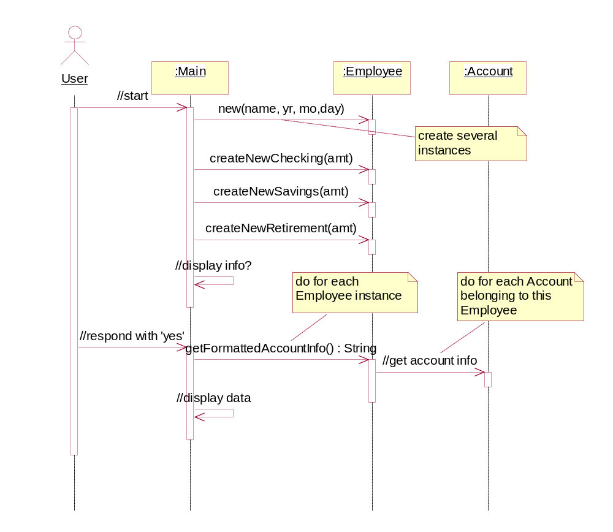

What you need to do:

For Phase I, you will need to fill in code in the classes Main and Employee (plan on using the Account class that you created in Lab 4-1).

Main

If the user answers 'yes', you need to call the getFormattedAccountInfo method in Main, and then display the return value to the console. You will also need to implement the method getFormattedAccountInfo. This method will call the getFormattedAcctInfo method of each of the Employee instances, and then put those Strings together into a good format.
Employee

- implement each of the createNewXXX methods by creating a new instance of Account with the appropriate data, and storing the new instance in the appropriate instance variable in Employee
- implement the deposit() method by calling the makeDeposit() method on the appropriate Account instance.
- implement the withdraw() method as follows: Call the appropriate makeWithdrawal method on the appropriate Account instance and then use the return value as the new return value for withdraw().
- implement the getFormattedAccountInfo() by calling the toString() method on each Account instance to provide its own formatted representation of its own account type and balance. The getFormattedAccountInfo method should then piece these 3 Strings together, and return the result. Note: your Account class already has an implementation of toString(); you may need to modify the implementation of this method in order to obtain the desired output format.

- add “getter” methods for the name and hireDate fields.
Here is the expected output of your program, in the console application (for Phase I):

See a report of all account balances? (y/n) y
ACCOUNT INFO FOR Jim Daley:

Account type: checking
Current bal: 10500.0
Account type: savings
Current bal: 1000.0
Account type: retirement
Current bal: 9300.0

ACCOUNT INFO FOR Bob Reuben:

Account type: checking
Current bal: 34000.0
Account type: savings
Current bal: 27000.0

ACCOUNT INFO FOR Susan Randolph:

Account type: checking
Current bal: 10038.0
Account type: savings
Current bal: 12600.0
Account type: retirement
Current bal: 9000.0

Class Diagram. The following diagram – called a class diagram -- displays the instance fields and instance methods of classes Main, Employee, and Account and shows the simple relationships between these classes. The arrows indicate directions of "messages" from one class to another; if a line has no arrow, it means that "messages" can be passed in either direction. Notice that Main communicates only with Employee, not with Account.

Note that multiplicities still need to be entered into the diagram.
For AccountType you do Not have to use an ‘enum’. You can handle this as we did before.

